**San Francisco Bay University**

**CS350 - Data Structures**

**Homework Assignment #5**

**Due day: 3/24/2023**

**Instructions:**

**a. Push the source code to GitHub**

**b. Please follow the code style rule like programs on handout.**

**c. Overdue homework submission can’t be accepted.**

**d. Take academic honesty and integrity seriously (Zero Tolerance of Cheating & Plagiarism)**

1. Write a function/method to sort *char* type elements in **stack** by **ONLY** temporary **stack** (shown in the example programs) or one variable without using list. For example, given a stack *stk*, the result should be as follows after calling ***srt(stk)***

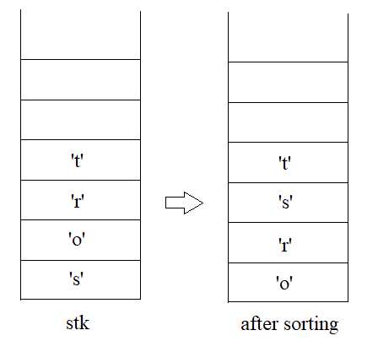

1. Assuming that there is a series of *int* type values in **stack**, such as

*stck ->"****5 3 2 10 6 8 1 4 12 7 4****",* write a program to get **next** bigger value for **each** element ONLY using **stack** allowed operations, like ***5->10, 3->10, 2->10, 10->12, 6->8, 8->12, 1->4, 4->12, 12->none, 7->none, 4->none***

1. Given a **stack** saving a group of *int* type values from the bottom to the top, find whether or not there exist pair values in consecutive sequence for all elements by a program and print these pairs. For instance, two stacks are as follows

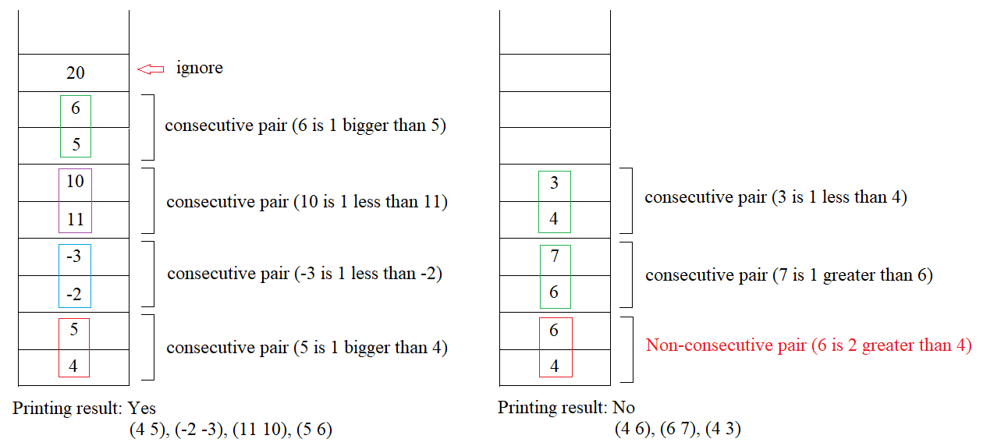

1. In an algebraic expression, such as ***"x – (y + z)"***, generate a function/method based on **stack** operations to rewrite it without parenthesis, like ***"x – y – z"***, ONLY considering + and – operators in this expression. If an expression is ***"x – (y – z – (u+v) ) – w"****,* the new format should be***"x – y + z + u + v – w"***after function/method call